Name: Alveena Naz
Reg No. FA25-BSE-010
OOP Graded Tasks Lab 12

Task 1:
import javax.swing.JFrame;
import javax.swing.JButton;
import javax.swing.JTextField;
import java.awt.*;
import javax.swing.JPanel;
public class Calculator extends JFrame {
Calculator(){
JPanel p1 = new JPanel();
p1.setLayout(new GridLayout(4,4));

String[] num = {"7","8","9","/","4","5","6","*","1","2","3","-","0",".","=","+"};
//add this into p1 in the form of buttons
for(int i =0;i<num.length;i++){
p1.add(new JButton(num[i]));
}

JPanel p2 = new JPanel();
p2.setLayout(new BorderLayout());
p2.add(new JTextField(), BorderLayout.NORTH);
p2.add(p1,BorderLayout.CENTER);

add(p2,BorderLayout.CENTER);
}
public static void main(String[] args) {
Calculator c = new Calculator();
c.setTitle("Calculator");
c.setSize(400,300);
c.setDefaultCloseOperation(JFrame.EXIT_ON_CLOSE);
c.setLocationRelativeTo(null);
c.setVisible(true);
}

}
OUTPUT:
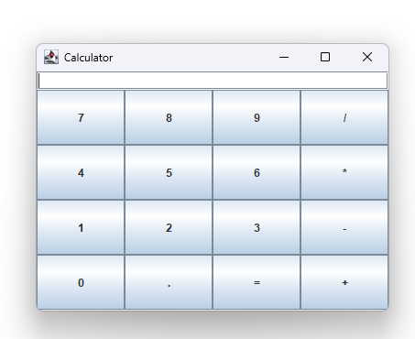

Task 2:
import javax.swing.JFrame;
import javax.swing.JButton;
import javax.swing.JTextField;
import java.awt.*;
import javax.swing.JPanel;

public class JavaApplication45 extends JFrame{

JavaApplication45(){
JPanel p1 = new JPanel();
JPanel p2 = new JPanel();
JPanel p3 = new JPanel();
// buttons
JPanel p4 = new JPanel();
// main pannel
JPanel p5 = new JPanel();

p4.setLayout(new GridLayout(1,3));
p5.setLayout(new FlowLayout());

p1.setBackground(Color.red);
p2.setBackground(Color.blue);
p3.setBackground(Color.pink);

p4.add(p1);
p4.add(p2);
p4.add(p3);

JButton b1 = new JButton("Red");
b1.setBackground(Color.red);
JButton b2 = new JButton("Blue");
b2.setBackground(Color.blue);
JButton b3 = new JButton("Pink");
b3.setBackground(Color.pink);

p5.add(b1);
p5.add(b2);
p5.add(b3);

add(p4,BorderLayout.CENTER);
add(p5,BorderLayout.SOUTH);

}
public static void main(String[] args) {
JavaApplication45 frame = new JavaApplication45();
frame.setTitle("Show GridLayout");
frame.setSize(500,500);
frame.setLocationRelativeTo(null);
frame.setDefaultCloseOperation(JFrame.EXIT_ON_CLOSE);
frame.setVisible(true);
}

}
OUTPUT:
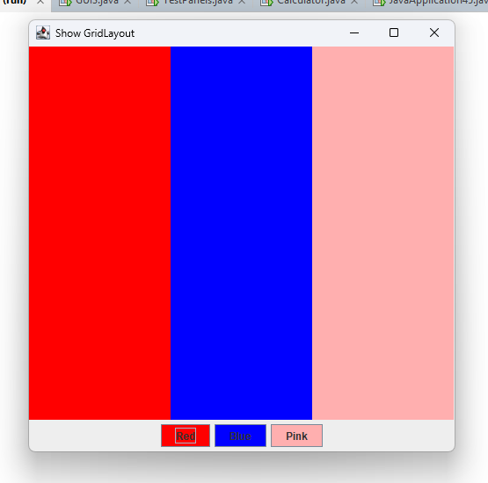

Task 3:
import javax.swing.JFrame;
import javax.swing.JButton;
import javax.swing.JTextField;
import java.awt.*;
import javax.swing.JPanel;
public class Task3 extends JFrame{
Task3(){
JPanel p1 = new JPanel();
p1.setLayout(new GridLayout(2,3,5,5));

JButton b1 = new JButton("One");
JButton b2 = new JButton("Two");
JButton b3 = new JButton("Three");
JButton b4 = new JButton("Four");
JButton b5 = new JButton("Five");
JButton b6 = new JButton("Six");
p1.add(b1);
p1.add(b2);
p1.add(b3);
p1.add(b4);
p1.add(b5);
p1.add(b6);

add(p1, BorderLayout.CENTER);
}

public static void main(String[] args) {
Task3 frame = new Task3();
frame.setTitle(" GridLayout");
frame.setSize(300,300);
frame.setLocationRelativeTo(null);
frame.setDefaultCloseOperation(JFrame.EXIT_ON_CLOSE);
frame.setVisible(true);

}

}
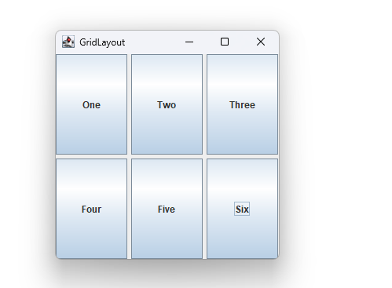

Task 4:
import javax.swing.JButton;
import javax.swing.JTextField;
import java.awt.*;
import javax.swing.JPanel;
import javax.swing.JFrame;
public class Task4 extends JFrame{
Task4(){
JPanel p1 = new JPanel();
p1.setLayout(new BorderLayout());
p1.setBackground(Color.GRAY);
JPanel p2 = new JPanel();
p2.setLayout(new FlowLayout());

JButton b1 = new JButton("Button 1");
JButton b2 = new JButton("Button 2");
JButton b3 = new JButton("Button 3");
JButton b4 = new JButton("Button 4");
JButton b5 = new JButton("Button 5");

p2.add(b1);
p2.add(b2);
p2.add(b3);
p2.add(b4);
p2.add(b5);

add(p1,BorderLayout.CENTER);
add(p2,BorderLayout.SOUTH);

}

public static void main(String[] args) {
Task4 frame = new Task4();
frame.setTitle(" GridLayout");
frame.setSize(500,500);
frame.setLocationRelativeTo(null);
frame.setDefaultCloseOperation(JFrame.EXIT_ON_CLOSE);
frame.setVisible(true);
}

}
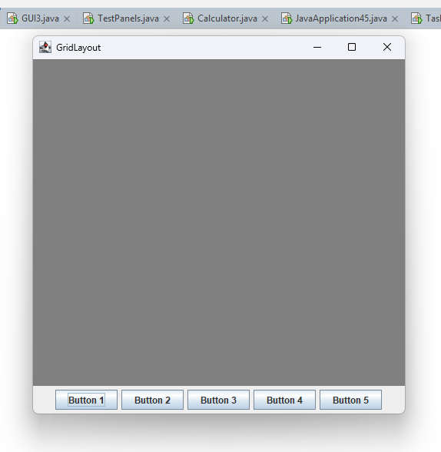

Task 5:
import javax.swing.JButton;
import javax.swing.JTextField;
import java.awt.*;
import javax.swing.JPanel;
import javax.swing.*;

public class Task5 extends JFrame{
Task5(){
JTextArea area = new JTextArea();
area.setText("Some people know how to write and write and write and write and write and some more");
JScrollPane pane = new JScrollPane(area);
add(pane, BorderLayout.CENTER);
JPanel p1 = new JPanel();

p1.setLayout(new FlowLayout(FlowLayout.CENTER, 10, 10));

JButton b1 = new JButton("Save Memo 1");
JButton b2 = new JButton("Save Memo 2");
JButton b3 = new JButton("Clear");
JButton b4 = new JButton("Get Memo 1");
JButton b5 = new JButton("Get Memo 2");

p1.add(b1);
p1.add(b2);
p1.add(b3);
p1.add(b4);
p1.add(b5);

add(p1, BorderLayout.SOUTH);

}
public static void main(String[] args) {
Task5 frame = new Task5();
frame.setTitle(" GridLayout");
frame.setSize(600,600);
frame.setLocationRelativeTo(null);
frame.setDefaultCloseOperation(JFrame.EXIT_ON_CLOSE);
frame.setVisible(true);
}

}

OUTPUT:
